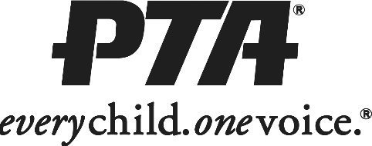

2018-2019 New Heights Elementary PTA

Membership Form

Name

Relationship to Student

**Do you prefer to be contacted by:**

E-mail

Home Phone

Cell Phone

Parent Grandparent

Teacher Staff

Other

(please check one)

Street Address

City, State, ZIP

E-mail Address

Home Phone Cell Phone

Student Name(s) Teacher Grade

Are you interested in participating as a:

Volunteer

Committee Member

Officer / Board Member

Membership is $5 per person. Checks payable to New Heights Elementary PTA.